Following issues found, please have a look in detail and see

1. when you select window size 25.6 and DFT size 256 and open include Spectrogram and Reassigned Spectrogram than origanl XKL and GTK based plot for Reassigned plot does not match with xkl plot. (Spectrogram plot matched )

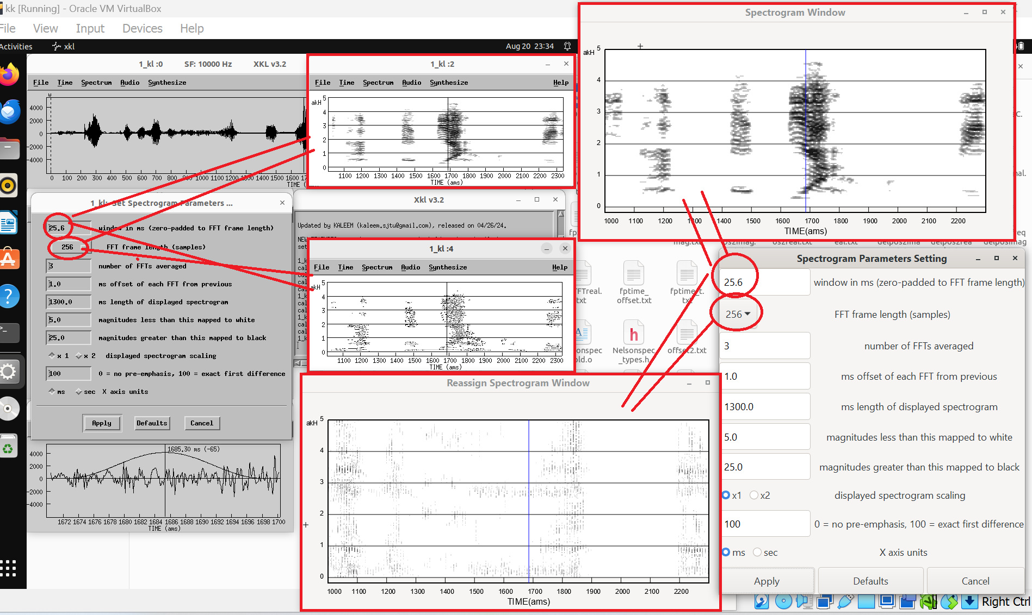

1. When you include spectrogram and Reassigned spectrogram plot than its standard size of plot time is set 1300 , but when you see graph it start from 1000 to 2200 but Orignal in xkl it is from 1100 to 2300

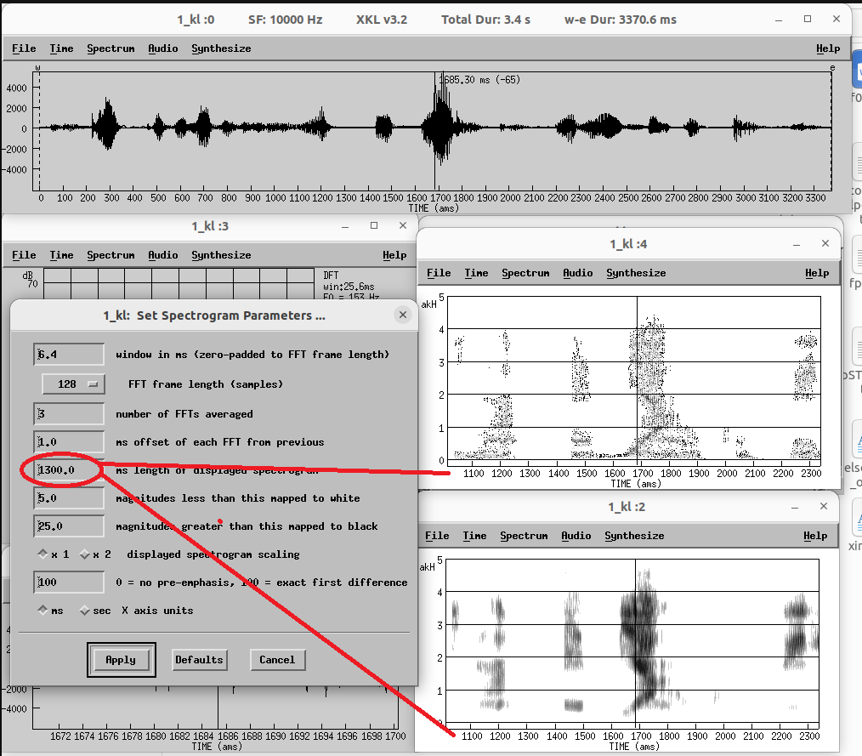

So when input value is 1300 in both than plot should be at same scale

1. the Zoom window of orignal xkl have smoothed scale on it but your GTK smoothed scale is missing

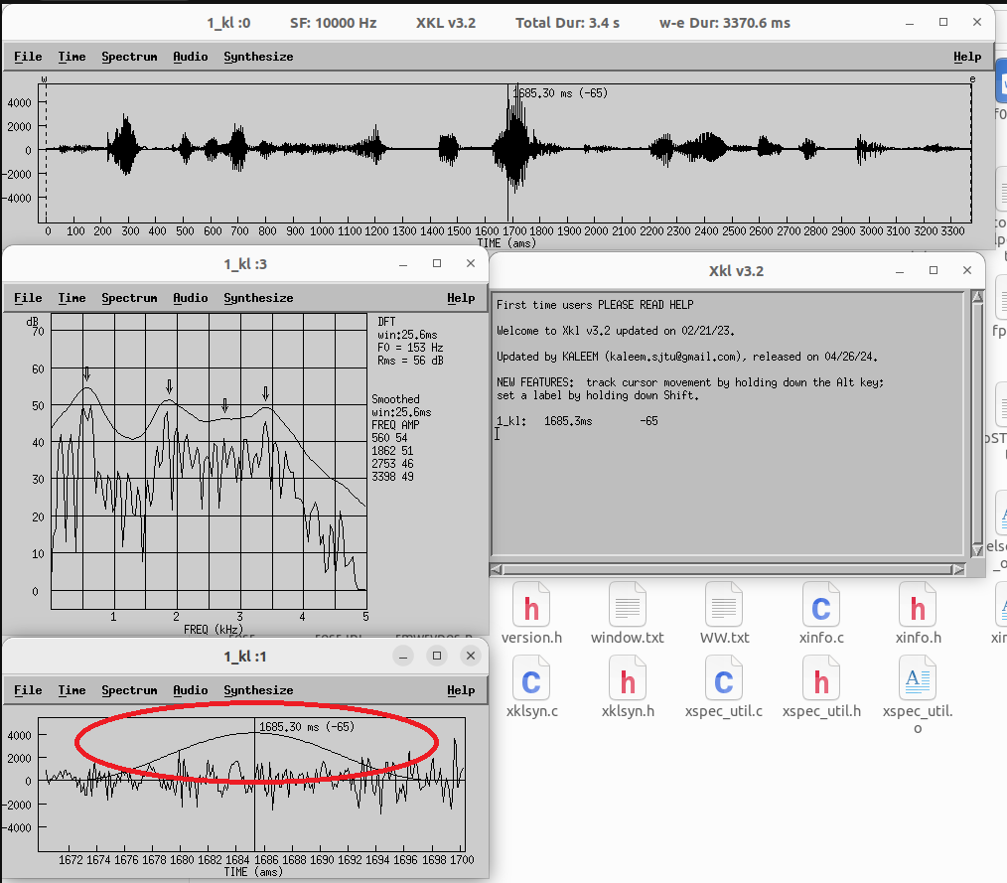

4) In origanl xkl when we include Spectrogram and Reassigned Spectrogram than cursor can move inside graph and we can click at any piont in graph but in GTK based graph we can not see cursor and also can not click on graph